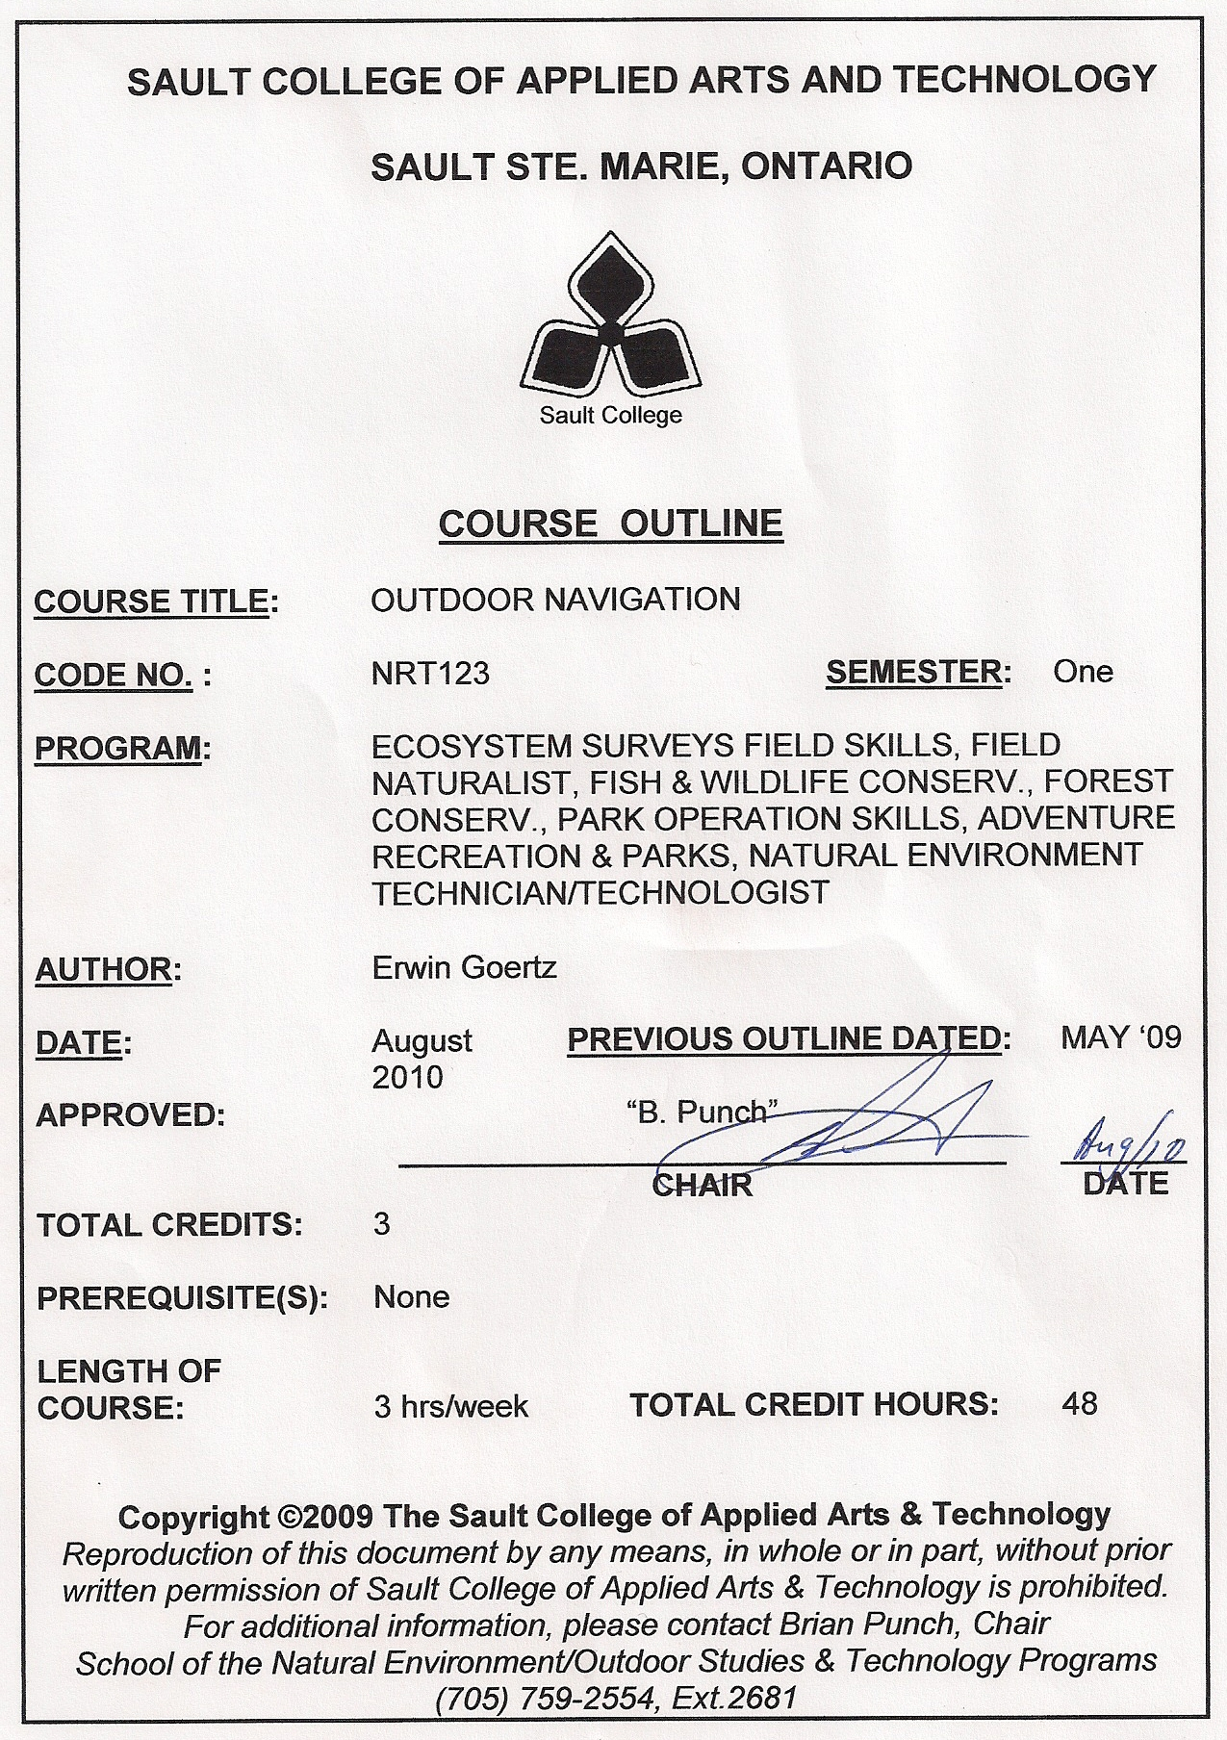

II. | LEARNING OUTCOMES AND ELEMENTS OF THE PERFORMANCE:
 | Upon successful completion of this course, the student will demonstrate the ability to:
 | 1. | Be able to use a magnetic hand compass and navigate to within 5% accuracy of the destination.
Potential Elements of the Performance:
- determine azimuths and bearings and covert from one to the other
- understand and set magnetic declination on a compass
 | 2. | Be able to pace to within 5% accuracy and measure distances using a 50 m rope and a 30 m tape to within 0.5% accuracy.
Potential Elements of the Performance:
- determine pacing factor and be able to pace distances in summer and winter
- understand the measurement divisions for a 30 m tape and a
50 m rope
- be able to maintain and properly store equipment
 | 3. | Be able to use OMNR aerial photographs, OBM and NTS maps in order to travel from one location to another using a magnetic hand compass.
Potential Elements of the Performance:
- understand scales of photographs and maps
- identify major features on aerial photographs and cover type changes
- be able to measure distances and directions on aerial photographs and maps
- be able to calculate directions on a map and aerial photograph using a navigational protractor
 | 4. | Be able to view aerial photographs in three dimensions.
Potential Elements of the Performance:
- define stereoviewing, stereoscope, stereopair and stereogram
- list two types of stereoscopes and the advantages/disadvantages of each
- correctly orient a stereopair of aerial photographs for stereoviewing
- correctly handle and take care of OMNR aerial photographs
- be able to order existing aerial photography from the provincial government
 | 5. | Be able to use and understand the principles of Global Positioning Systems (GPS)
Potential Elements of the Performance:
- understand the accuracy of GPS units
- be able to mark (enter) a field position in the GPS while in the field
- be able to enter a field position using map co-ordinates
- be able to navigate to waypoints entered into the GPS using a compass and GPS
- be able to record positions from the GPS onto a map
 | 6. | Be able to determine areas on maps using a dot grid, the line transect method and a digital planimeter.
Potential Elements of the Performance:
- determine the number of hectares per dot on a dot grid for any given map scale
- know how to handle dots that fall on the area boundary
- know the components/keys on a digital planimeter & how to use it
- understand the principles which allow us to calculate (measure)
 | 7. | Use and interpret topographic maps (OBM, NTS). This includes being able to accurately reference any point using latitude/longitude as well as UTM co-ordinates.
Potential Elements of the Performance:
- recognize the different ways of expressing scale
- identify all lines, numbers and symbols on maps
- recognize the divisions used on a map to measure long/lats and UTM co-ordinates
- draw topographic profiles
- be able to read contour lines and determine major topographic features
 | 8. | Correctly use mapping signs and symbols in the process of preparing maps and field notes.
Potential Elements of the Performance:
- be able to convert from one unit of measurement (paces/metres) to another
- record field information legibly on tally sheets using proper symbols
- be able to prepare field notes/maps
 | 9. | Use basic equipment including the metric scale, distance measurement devices, and navigational protractor.
Potential Elements of the Performance:
- use the metric scale for distance measurements on a variety of maps
- measure directions and apply magnetic declination on maps using a navigational protractor
- properly use a distance measurement device.

III. | TOPICS:
 | 1. | Introduction to course, lettering style, units of measurement and conversions.
 | 2. | Compassing
 | 3. | Determining directions indoors and outdoors
 | 4. | Measuring distances
 | 5. | Determining distances indoors and outdoors
 | 6. | Grid networks
 | 7. | GPS
 | 8. | OMNR aerial photographs
 | 9. | Stereoviewing and determining directions in the field using aerial photographs
 | 10. | Field Mapping
 | 11. | Area determination
 | 12. | Topographic maps and reading contours

IV. | REQUIRED RESOURCES/TEXTS/MATERIALS:  - Outdoor Navigation course manual  - NTS 1:50 000 Topographic Map Sheets #41 K/9  - Metric Scale (1:500 to 1:2500)  - Navigational Protractor  - HB Pencil  - Calculator  - Clipboard  - Dot Grid (provided by instructor)  - Personal Safety Whistle (Fox 40 fluorescent orange)  - Suunto MC2-DL Compass or Silva Ranger Compass  - Pocket Stereoscopes (2 power)

V. | EVALUATION PROCESS/GRADING SYSTEM:  Evaluation will be based on weekly quizzes, assignments handed out in class, assignments to be completed in the field and tests.  - Quizzes 10%  - Assignments 40%  - Tests (2) 50%  100%  Quizzes are given at the beginning of each class. Students who are late for class will forfeit the quiz mark. Assignments which are conducted in the field must have a passing grade of 50%. Assignments are due on specific dates. The instructor will review and correct the answers for the questions on late assignments, however, the student forfeits the marks for these. Under special circumstances, which will be verified, students may be given credit for late assignments. Students will repeat any unsatisfactory assignments until satisfactorily completed. All field trips are mandatory. Students missing a field trip without adequate reason or proof are penalized 5% for each trip missed.

The following semester grades will be assigned to students:

 | Grade | Definition | Grade Point Equivalent
 | A+ | 90 - 100% | 4.00
 | A | 80 - 89% | 4.00
 | B | 70 - 79% | 3.00
 | C  D | 60 - 69%  50 - 59% | 2.00  1.00
 | F (Fail) | 49% or below | 0.00
 | CR (Credit) | Credit for diploma requirements has been awarded.
 | S  U | Satisfactory achievement in field/clinical placement or non-graded subject areas.  Unsatisfactory achievement in field/clinical placement or non-graded subject areas.
 | X | A temporary grade limited to situations with extenuating circumstances giving a student additional time to complete the requirements for a course.
 | NR  W | Grade not reported to Registrar's office.  Student has withdrawn from the course without academic penalty

VI. | SPECIAL NOTES:
Course Outline Amendments:
The professor reserves the right to change the information contained in this course outline depending on the needs of the learner and the availability of resources.

Retention of Course Outlines:
It is the responsibility of the student to retain all course outlines for possible future use in acquiring advanced standing at other postsecondary institutions.

Prior Learning Assessment:
Students who wish to apply for advance credit transfer (advanced standing) should obtain an Application for Advance Credit from the program coordinator (or the course coordinator regarding a general education transfer request) or academic assistant. Students will be required to provide an unofficial transcript and course outline related to the course in question. Please refer to the Student Academic Calendar of Events for the deadline date by which application must be made for advance standing.

Credit for prior learning will also be given upon successful completion of a challenge exam or portfolio.

Substitute course information is available in the Registrar's office.

Disability Services:
If you are a student with a disability (e.g. physical limitations, visual impairments, hearing impairments, or learning disabilities), you are encouraged to discuss required accommodations with your professor and/or the Disability Services office. Visit Room E1101 or call Extension 2703 so that support services can be arranged for you.

Communication:
The College considers WebCT/LMS as the primary channel of communication for each course. Regularly checking this software platform is critical as it will keep you directly connected with faculty and current course information. Success in this course may be directly related to your willingness to take advantage of the Learning Management System communication tool.

Plagiarism:
Students should refer to the definition of “academic dishonesty” in Student Code of Conduct. A professor/instructor may assign a sanction as defined below, or make recommendations to the Academic Chair for disposition of the matter. The professor/instructor may (i) issue a verbal reprimand, (ii) make an assignment of a lower grade with explanation, (iii) require additional academic assignments and issue a lower grade upon completion to the maximum grade “C”, (iv) make an automatic assignment of a failing grade, (v) recommend to the Chair dismissal from the course with the assignment of a failing grade. In order to protect students from inadvertent plagiarism, to protect the copyright of the material referenced, and to credit the author of the material, it is the policy of the department to employ a documentation format for referencing source material.

Student Portal:
The Sault College portal allows you to view all your student information in one place. mysaultcollege gives you personalized access to online resources seven days a week from your home or school computer. Single log-in access allows you to see your personal and financial information, timetable, grades, records of achievement, unofficial transcript, and outstanding obligations, in addition to announcements, news, academic calendar of events, class cancellations, your learning management system (LMS), and much more. Go to https://my.saultcollege.ca.

Electronic Devices in the Classroom:
Students who wish to use electronic devices in the classroom will seek permission of the faculty member before proceeding to record instruction. With the exception of issues related to accommodations of disability, the decision to approve or refuse the request is the responsibility of the faculty member. Recorded classroom instruction will be used only for personal use and will not be used for any other purpose. Recorded classroom instruction will be destroyed at the end of the course. To ensure this, the student is required to return all copies of recorded material to the faculty member by the last day of class in the semester. Where the use of an electronic device has been approved, the student agrees that materials recorded are for his/her use only, are not for distribution, and are the sole property of the College.

Attendance:
Sault College is committed to student success. There is a direct correlation between academic performance and class attendance; therefore, for the benefit of all its constituents, all students are encouraged to attend all of their scheduled learning and evaluation sessions. This implies arriving on time and remaining for the duration of the scheduled session.

Tuition Default:
Students who have defaulted on the payment of tuition (tuition has not been paid in full, payments were not deferred or payment plan not honoured) will be removed from placement and clinical activities. This may result in loss of mandatory hours or incomplete course work. Sault College will not be responsible for incomplete hours or outcomes that are not achieved or any other academic requirement not met as of the result of tuition default. Students are encouraged to communicate with Financial Services with regard to the status of their tuition prior to this deadline to ensure that their financial status does not interfere with academic progress.

